Very Short Blurb next to picture on directory
Mechanisms and models of photosynthesis; fluxes of metabolites during primary metabolism
(longer research blurb below)
Resolving photosynthetic fluxes in a changing world
Photosynthesis drives life on this planet by providing the oxygen, food and energy required to support “higher” life forms – including us humans. With increasing population, and accompanying changes in consumption and climate, it is vital to understand how photosynthesis will respond to these greater challenges and explore opportunities to hack it to produce more food, fuel and fiber more sustainably. Research in our lab therefore focuses on resolving the biochemical, cellular and canopy-level mechanisms that determine photosynthetic fluxes of carbon and oxygen with the end goal to better model plant response to climate change and engineer more efficient crops.
Figure 1: Above is an example of how modeling can be used to understand plant performance under dynamic conditions. Shown is how much crop yield is decreased by a photorespiration; a byproduct of photosynthesis and an area of special interest to the Walker lab. Taken from Walker, VanLoocke, Bernacchi and Ort (2016) The costs of photorespiration to food production now and in the future. Annual review of plant biology (67).

If we can’t model or measure it, we don’t understand it
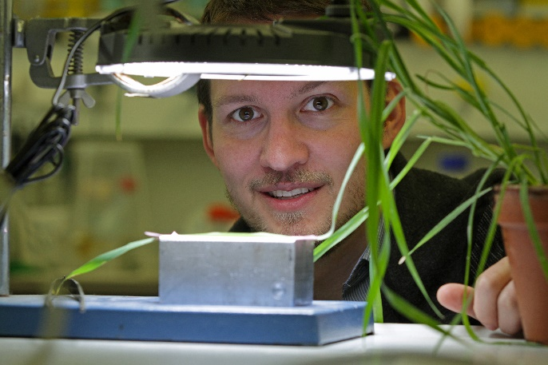
For many years, we have been able to use classic methods in gas and energy exchange to understand on a net level how much carbon dioxide a plant takes up or how much oxygen it produces from water splitting under a given condition. These measurements helped produce elegant models that connect plant ecophysiology with biochemistry and are currently used to estimate how ecosystems or crop yields respond to future changes in temperature or carbon dioxide concentration. While these models are good, they rely on many assumptions which have not yet been validated – especially under increased temperatures. Our lab challenges these assumptions using next-generation advances in metabolic flux analysis and isotopic gas exchange analysis to understand how the models can be improved to better represent plant responses to increased temperature.
Figure 2: Good models are rooted in solid experimental discovery and solid experimental work is shaped by emergent models. For this reason, the Walker lab employs both to discover new aspects of plant biology and better quantify the impact of changing climate to plant performance. Photo Credit: Jochen Mueller

If we don’t understand it, we can’t make it better
As we develop improved models of carbon dioxide fixation and related metabolic fluxes, we identify targets for improving photosynthesis. We then implement these targets in silico or in living plants to see if the results are improved photosynthesis. We can also use these refined models to determine if we can make more accurate predictions about the response of plants to changing conditions.

We need you
If you have made it this far and are interested in learning more, please contact Berkley directly. The lab is in current need of students and postdocs looking to work hard to push forward cutting edge science.

Key Publications (Full list in Google Scholar)
- Berkley J. Walker, Andy VanLoocke, Rebecca A. Slattery, Darren Drewry and Donald R. Ort. Chlorophyll can be reduced in crop canopies with little penalty to crop photosynthesis. Accepted. Plant Physiology
- Berkley Walker, Andy VanLoocke, Carl J. Bernacchi and Donald R. Ort. (2016) The costs of photorespiration to food production now and in the future. Annual Review of Plant Biology 67, 107-129.
- Berkley Walker and Donald R. Ort. (2015) Improved method for measuring the apparent CO₂ photocompensation point resolves the impact of multiple internal conductances to CO₂ to net gas exchange. Plant Cell & Environment 38 (11), 2462-2474.

